Multilingual Dictionary

What is Multilingual Dictionary
# Source: AI Source: Provided by: [Data Path: Persons Table -> ID Column: 1, Name_En Column: Motasem Essam] -> From: [Chatgpt (GPT-4-turbo)] on [7/29/2025]
A Multilingual Dictionary provides translations and definitions of words across more than two languages. Unlike bilingual dictionaries (which deal with two languages), multilingual dictionaries offer parallel vocabulary entries in three or more languages, making them useful in multilingual communication, education, and translation.

🔹 Key Features of a Multilingual Dictionary
# Source: AI Source: Provided by: [Data Path: Persons Table -> ID Column: 1, Name_En Column: Motasem Essam] -> From: [Chatgpt (GPT-4-turbo)] on [7/29/2025]
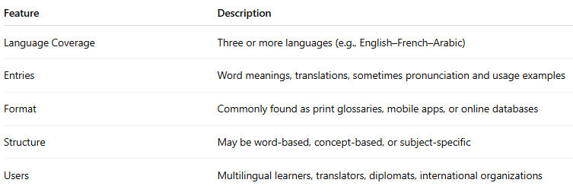
Feature | Description
Language Coverage | Three or more languages (e.g., English–French–Arabic)
Entries | Word meanings, translations, sometimes pronunciation and usage examples
Format | Commonly found as print glossaries, mobile apps, or online databases
Structure | May be word-based, concept-based, or subject-specific
Users | Multilingual learners, translators, diplomats, international organizations

🔹 Examples of Multilingual Dictionaries
# Source: AI Source: Provided by: [Data Path: Persons Table -> ID Column: 1, Name_En Column: Motasem Essam] -> From: [Chatgpt (GPT-4-turbo)] on [7/29/2025]
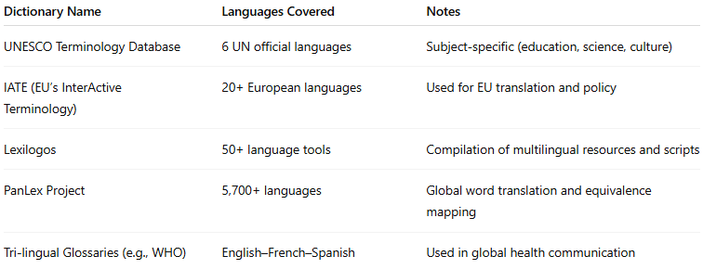
Dictionary Name | Languages Covered | Notes
UNESCO Terminology Database | 6 UN official languages | Subject-specific (education, science, culture)
IATE (EU’s InterActive Terminology) | 20+ European languages | Used for EU translation and policy
Lexilogos | 50+ language tools | Compilation of multilingual resources and scripts
PanLex Project | 5,700+ languages | Global word translation and equivalence mapping
Tri-lingual Glossaries (e.g., WHO) | English–French–Spanish | Used in global health communication

🔹 Advantages
# Source: AI Source: Provided by: [Data Path: Persons Table -> ID Column: 1, Name_En Column: Motasem Essam] -> From: [Chatgpt (GPT-4-turbo)] on [7/29/2025]
- Supports multilingual communication and translation
- Reduces need to consult multiple bilingual dictionaries
- Promotes cross-cultural literacy and comparative linguistics
- Ideal for international organizations, agencies, and NGOs

🔹 Use Cases
# Source: AI Source: Provided by: [Data Path: Persons Table -> ID Column: 1, Name_En Column: Motasem Essam] -> From: [Chatgpt (GPT-4-turbo)] on [7/29/2025]
- International diplomacy and policy-making
- Multilingual education and curriculum design
- Translation of technical, legal, and medical materials
- Language technology and computational linguistics

